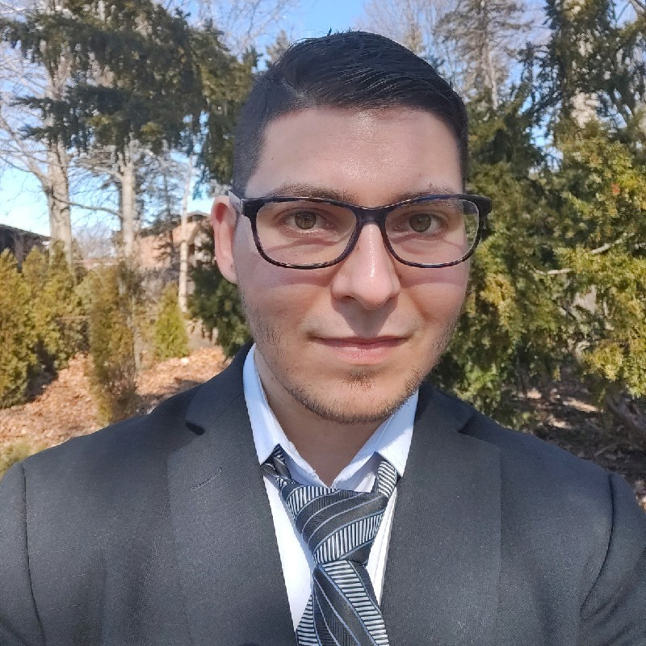

**HiL Simulation Engineer**

**BS in Mechatronics Engineering**

Date of birth: 30-Mar-1993

Adress: Allen Park, Michigan, US

Email: [axel_ing93@hotmail.com](mailto:axel_ing93@hotmail.com)

Linkedin profile: [Linkedin Profile](https://www.linkedin.com/in/axel-gerardo-aguilar-gaxiola-917315b7/)

Phone: +1 313 770 4987

**Axel Aguilar**

**EDUCATION**



**2012 - 2016**

**BS in Mechatronics Engineering**

CETI colomos

**2008 - 2012**

**Instrumentation & Control Technologist**

CETI colomos

***Languages:***

**Español:** Native

**English:** EFSET Grade **C1**

**German: A1**

**Overview**

**- 5 years of experience in Automotive & Electronics Industry**

**Aug 2020 – Current Role**

**Ford Motor Company, Sector: Education**

**Current position: HiL Test Simulation Engineer**

*Support to new vehicle programs of Ford motor

*Phone automation project Python and DSpace

*Real vehicle test and data record for post issue analysis

*SW updates to and breadboard maintenance for all modules

*Development of new test solutions for upcoming programs

*High Voltage commissioning for electric and hybrid vehicles

*Seat box graphics screen project for signal monitoring and control

**Oct 2018 – Aug 2020**

**Vitescco Technologies, Sector: Automotive**

**Position: Software Test Automation Engineer**

*Development of scripts for automated testing of Electric and Hybrid-Electric Vehicles for **Ford** and **GM** projects.

*Hands on experience with physical loads and actuators connected in breadboard (BoB) of DSPace simulators.

*Experience in Test Bench laboratory, electrical debugging of signal behaviors using different stimulation inputs.

*Development of interfaces between Engine Simulator and Electronic Control Unit.

*Experience with Module testing and Regression testing, electrical and software validation of simple IO and some complex functionalities.

*Support Test Automation Platform with Python Scripts

*Perform regression test of ECU.

*Experience using HIL DSpace equipment and harnesses in test bench Laboratory, usage of debug tool such as osciloscope.

*Evaluation and analysis of test reports generated by Test Automation framework

**Dic 2017 – Oct 2018**

**Continental Santa Anita, Sector: Automotive**

**Position: Software Developer**

*Real Vehicle testing

*Development of Traction Control System of Can-am spyder motorcycle

*Working on sw tasks regarding brakes and steering wheel angle sensor

*Simulation of vehicle events in test bench lab

OEM’s: **Polaris, CAN-Am**

**Jul 2016 – Dic 2017**

**Continental Periférico, Sector: Automotive**

**Position: Process Engineer**

*Working in developing new calibration values in production technologies using statistical tools, such as Laser Welding, Heat Staking, Pointer Press and Single Pin Insertion processes. OEM’s: **Ford, VW, Nissan, GM, Toyota**.

\***Design of experiments** for production technologies.

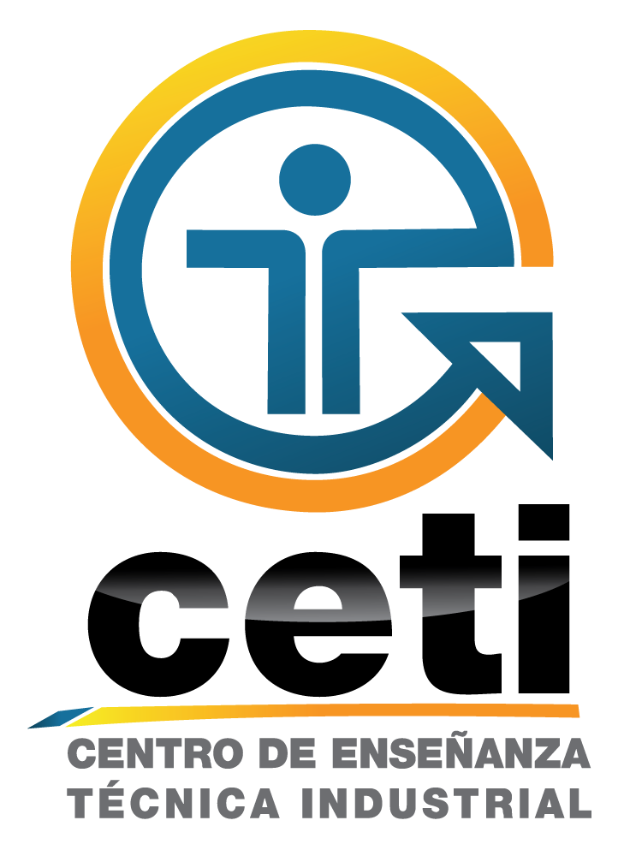



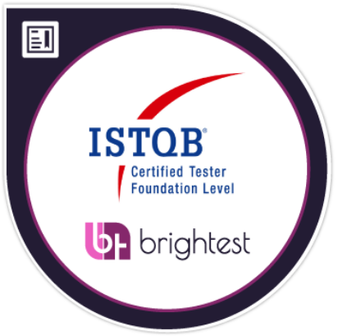

**COURSES AND DIPLOMAS**

**Sep 2019 – ISTQB**

Certified Tester Foundation Level

**Jul 2017 - Executrain**

Excel Macros – Visual Basic for applications, 16 Hours.

**May 2017 - Talent Mind**

Project Management Seminar, 24 Hours.



**Jan 2014 – COMPUTEC**

Executive course of AUTOCAD Básic & Advanced 2D y 3D, 50 Hours

**Dec 2013 - Iteso – Nokia**

Windows Phone, 24 Hours

2nd place in programming of mobile applications contest.

*Auditive diagnosis App

**SOFTWARE & TOOLS**



**HIL testing & SW development frameworks:**

-Lauterbach -ATI -MKS / IMS -DSpace -Jenkins

-INCA -CANoe -Eclipse -Labcar -Git

**Programming languages:**

Strong Python + OOP

Embeeded C / C++

**Control systems:**

Matlab (Simulink) & LabView

**Office:**

Word, Exel, Power Point, Visio, Project

**Statistical analysis:**

Minitab, R

**HW Frameworks:**

NI Multisim, Proteus,

PCB Cam tool

**Project Mgmt:**

X-mind, Project, Jira (Agile)

**KEY KNOWLEDGE**

Product Life Cycle, CAN, Software Testing and Debugging, Z – Transformation, Software Design, Calibration, ASPICE, Statistical analysis of data, Vehicular Dynamics, Embeeded systems, Mathematical Modeling, UML basics, Developing of Virtual Instruments, Digital Electronics, Vector tools.

**SKILLS**

*Analytical skills

*Negotiation skills

*Self-taught

*Courtesy

*Proactive

*Responsible

*Adaptable

*Team player

*Innovation

*Leadership

*Punctuality

*Focus on results



**CAREER ASPIRATIONS**

My passion is automation of validation tasks, which leads to higher quality standards.

I would like to study master’s degree in some in SW or Automotive field, even Machine Learning.